Journal of Climate Change and Sustainable Development Research , 15(S1), 204-233, Special Issue, 2026

 |   Homepage: https://JCCSD.com | 

Development of a Holistic Climate Change and Cities Framework (CCCF) for Urban Climate Change Adaptation, Mitigation, and Resilience
Faeze Shoja¹*, Mohammad Reza Farzaneh², Sayed Iman Ahmadi³
¹ Postdoctoral Researcher in Climatology, Department of Physical Geography, University of Tehran, Teheran, Iran. Faeze.shoja@yahoo.com
² Second
³ Third

ARTICLE INFO | ABSTRACT
KEYWORDS:  Climate Action, Climate Change, Overarching Themes, Resilient City, Social-Ecological Systems  *Corresponding Author:  Email: Iran. Faeze.shoja@yahoo.com  ‌  Phone: +98  ORCID:  DOI: | The present study aims to systematically analyze Climate Action Plans (CAPs) of leading global megacities and identify their physical, institutional, and financial transition patterns. The methodology is based on a combination of directed qualitative content analysis and frequency-statistical text assessment, operationalized within the theoretical framework of Social-Ecological Systems (SES). A total of 5,088 Descriptive Codes (DC) and 4,662 Interpretive Codes (IC) were extracted and examined from the climate action documents of six megacities: London, Copenhagen, Stockholm, Istanbul, Paris, and Barcelona. The findings reveal that these megacities have concentrated their attention on the "Actors System" with 1,323 interpretive codes (centered on energy transition, accounting for 56.2%), and the "Resources System" with 1,244 interpretive codes (centered on urban environment, accounting for 32.8%). In the governance domain (903 codes), urban climate governance ranks first with 45.8%, while the remarkably marginal share of climate finance (0.1%) is identified as the most critical operational bottleneck. Conversely, the spatial-physical system, with the lowest number of interpretive codes (211), remains at the bottom of implementation priorities. Comparative analysis of these documents demonstrates that a successful transition toward urban resilience requires a shift from supply-driven to demand-led planning models, the establishment of semi-independent energy agencies, and the adoption of innovative financing mechanisms such as Energy Performance Contracts (ESCOs) that place social justice and energy poverty alleviation at their core. These findings offer practical lessons for megacities in the Global South facing multiple intersecting challenges and can provide an operational framework for institutional redesign, smart financing, and climate-just spatial regeneration.
  Article History:
  Received: 21 December 2025
  Final revision: 05 February 2026
  Accepted: 16 May 2026
  Early online access: 16 May 2026
  Published:

Introduction
Cities, as primary hubs of economic growth and innovation, play a dual role in the climate change equation: on one hand, they are responsible for over 70% of global greenhouse gas emissions, and on the other, due to high population density and critical infrastructure, they are at the forefront of vulnerability to climate hazards such as flooding, heatwaves, drought, and sea-level rise (Zhang & Sharifi, 2024; Rahmani & Sharifi, 2025). This duality has positioned cities as the primary arena for climate action, such that local-level climate planning and implementation are recognized as among the most effective strategies for reducing vulnerability and enhancing urban resilience (Sharifi et al., 2025a, 2025b). Recent reports from the Intergovernmental Panel on Climate Change (IPCC) have emphasized the critical role of urban climate action in achieving sustainability and resilience goals, identifying cities as key actors in realizing the objectives of the Paris Agreement (IPCC, 2014, 2022a). Consequently, Climate Action Plans (CAPs) — strategic documents developed by local governments — have become central instruments for organizing, prioritizing, and implementing mitigation and adaptation measures (Aboagye & Sharifi, 2023; Cohen et al., 2025).
Despite the significant expansion of these plans globally, with over 9,000 cities committed to networks such as the Global Covenant of Mayors for Climate and Energy (GCoM) and more than 100 leading cities participating in the C40 network (C40 Cities, 2021; UNFCCC, 2022), recent scholarship has raised serious concerns regarding the effectiveness, quality, and inclusiveness of existing urban CAPs (Olazabal & Ruiz De Gopegui, 2021; Tiepolo, 2017; Hsu et al., 2020). Identified structural deficiencies include a lack of comprehensiveness, transparency, and integration, insufficient attention to social equity dimensions, and a persistent gap between ambitious targets and operational actions (Aboagye & Sharifi, 2024; Reckien et al., 2018; Cohen et al., 2025). Notably, research indicates that many cities, rather than articulating concrete implementation strategies, tend to rely on broad goal statements and soft, voluntary approaches, with limited use of hard regulatory instruments and direct physical interventions (Haarstad et al., 2024; Heikkinen et al., 2019). This raises fundamental questions regarding the actual effectiveness of these plans in fostering systemic transformation and achieving deep decarbonization targets.
Despite the abundance of existing research, a structural gap persists in the academic literature: comprehensive and systematic comparative analyses of CAP content in leading cities, particularly those extending beyond mere quantitative target-setting, remain scarce (Aboagye & Sharifi, 2023, 2026). Much of the existing scholarship is either confined to specific cities (predominantly in the Global North) (Lamb et al., 2019; Reckien et al., 2018) or focused exclusively on either mitigation or adaptation dimensions (Flórez Bossio et al., 2019; Juhola et al., 2022). Furthermore, studies examining the structure of conceptual linkages and thematic concentration patterns in these documents are rare and fragmented (Grafakos et al., 2020; Sharifi, 2020). Concurrently, despite growing emphasis on "climate justice" and "just transition" in global discourse, it remains unclear to what extent urban CAPs have addressed distributive and procedural equity dimensions and the identification of vulnerable groups (Caggiano et al., 2026; Hughes, 2020). This analytical gap not only hinders accurate assessment of plan effectiveness but also significantly impedes the learning process from successful experiences and the transfer of lessons to megacities in the Global South.
In response to these theoretical and practical imperatives, the present study aims to systematically analyze Climate Action Plans from six leading global megacities, London, Copenhagen, Stockholm, Istanbul, Paris, and Barcelona. The primary innovation of this research lies in moving beyond one-dimensional analyses by employing the Social-Ecological Systems (SES) framework (Ostrom, 2009) and Clark's (2019) qualitative content analysis model to evaluate these documents. The central research question is: which components of the urban system (e.g., resources, actors, governance, and spatial-physical dimensions) do these megacities prioritize in their plans, and what strategic implications does this paradigmatic shift, from hazard monitoring toward institutional agency, energy transition, and local governance, hold for designing climate action plans in developing-world megacities, particularly Tehran, which simultaneously confronts intersecting crises of resource imbalance, air pollution, and land subsidence? To address this question, the study employs directed qualitative content analysis and frequency analysis of interpretive and descriptive codes extracted from the documents, enabling the mapping of strategic priorities, identification of discursive gaps, conceptual linkage patterns, and thematic density distribution within these plans (Caggiano et al., 2026; Ascione et al., 2025). This multi-layered approach facilitates a deeper understanding of the hidden knowledge architecture of urban climate policymaking.
The significance of this research for megacities in the Global South, particularly Tehran, lies in the fact that the Iranian capital, with a population exceeding nine million within the urban area and over thirteen million in the metropolitan region, sits at the epicenter of the climate duality. Tehran, on one hand, bears a substantial share of national energy consumption, greenhouse gas emissions, and natural land-use degradation, while on the other, is subject to severe local climatic anomalies. Statistical trends over the past five decades confirm that Tehran has experienced an average annual temperature increase exceeding the global average, coupled with a significant decline in precipitation. These biophysical fluctuations have exposed the city's physical fabric to numerous systemic challenges, most notably the intensification of the urban heat island (exceeding 11°C in the city center and south), the water imbalance crisis and land subsidence at a rate of 25 cm per year, and the accumulation of air pollutants with PM2.5 concentrations at seven times the WHO standard. These threats demonstrate that climate change in Tehran is not a distant hypothesis but an objective reality that increasingly jeopardizes the physical, social, and biological sustainability of the capital. Therefore, extracting and critically adapting the roadmap of leading cities for Tehran's context can provide an operational pathway from fragility to resilience, offering valuable lessons in institutional capacity-building, smart financing, and spatial redesign for urban planners. The findings of this research can serve as a reference framework for developing climate action plans in Iranian megacities and other similarly situated developing-world cities.
The paper is organized as follows: the next section elaborates on the research methodology, including the SES-based analytical framework, the documents under investigation, the four-stage coding process, and the statistical and network analysis methods. The results section presents the statistical findings, including the distribution of interpretive codes across six main themes, network graph analysis, and the density distribution of concepts throughout the documents. The discussion section interprets these findings through a comparative analysis of the selected cities and extracts policy lessons. Finally, the conclusion synthesizes the findings, identifies discursive gaps, and proposes frameworks for developing-world megacities, particularly in the areas of institutional development, smart financing, and spatial redesign.
Materials and Methods
The present study aims to systematically analyze Climate Action Plans of leading global megacities and identify their physical, institutional, and financial transition patterns. This study employs a mixed-methods approach (quantitative-qualitative) and utilizes Directed Qualitative Content Analysis (Hsieh & Shannon, 2005). This method enables the systematic extraction of themes and interpretive codes from scientific texts and strategic documents.
The theoretical framework of this research is based on the Social-Ecological Systems (SES) theory, which analyzes the city as a dynamic, interconnected system in bilateral interaction with the natural and human environment (Ostrom, 2009). This framework, which has also been employed in previous studies to analyze climate change-related laws and documents (Farzaneh & Banimostafaarab, 2023, 2025; Farzaneh & Banimostafaarab, 2026), comprises six overarching themes that fall into two general categories:
a) Exogenous Systems: Factors that lie outside the direct control of urban management but influence the physical sustainability and functionality of the city:
- Macro Socio-Economic-Political Transformations: Includes variables such as national and international policies, investment flows, demographic changes, climate migration, and technological developments.
- Ecosystems and Natural Hazards: Includes global climate change, sea-level rise, changes in precipitation patterns, land subsidence, floods, droughts, and other extreme events.
b) Endogenous Systems: Factors that are under the direct control of urban management and the city's physical structure, allowing for planning and intervention:
- Resources: Includes water, energy, land, waste, biological resources, and other input and output flows of the urban system.
- Actors: Includes governmental and local institutions, citizens, the private sector, non-governmental organizations, the scientific community, and other stakeholders.
- Governance: Includes decision-making structures, laws and regulations, the financial system, institutional capacities, and public participation mechanisms.
- Spatial-Physical: Includes urban form, infrastructural networks (water, energy, transportation), land use, urban morphology, and the physical elements of the city.
In the first phase of this research, the primary objective was to extract an analytical-normative framework based on the dominant interpretive codes from the Climate Action Plans of leading global cities. To this end, the strategic documents of six leading global cities—London, Copenhagen, Stockholm, Istanbul, Paris, and Barcelona—which have well-established and transparent climate plans, were examined, along with the standard frameworks of global networks such as the C40 Climate Action Planning Framework (2018) and the City Climate Transition Framework (CCTF - 2025) (C40 Cities, 2021; City of Copenhagen, 2022; City of Stockholm, 2021; Greater London Authority, 2021; Istanbul Metropolitan Municipality, 2021; Ville de Paris, 2022; Ajuntament de Barcelona, 2021).
The coding and analysis process was implemented in four systematic steps based on Clarke's model (2019) (Braun & Clarke, 2019a, 2019b):
Step One, Descriptive Coding: The full text of the Climate Action Plans of the selected cities was examined line-by-line, and all statements related to the city and climate change were extracted as descriptive codes. In this stage, using an inductive-deductive approach, codes were identified both based on the initial framework (the six overarching SES themes) and based on emerging concepts within the texts (Hsieh & Shannon, 2005; Farzaneh & Banimostafaarab, 2025).
Step Two, Interpretive Coding: The descriptive codes were transformed into interpretive codes (more abstract concepts) through an analytical process utilizing the constant comparison method. For instance, descriptive codes related to "nocturnal temperature increase," "decreased precipitation," and "changes in wind patterns" were merged into the interpretive code "Urban Microclimate."
Step Three, Identification of Dominant Codes: For each of the six themes, the frequency of interpretive codes across all documents was calculated, and codes that appeared in more than 50% of the sources were selected as dominant interpretive codes. These codes formed the central core of the analytical framework of the research and served as the basis for all subsequent analyses.
Step Four, Final Organization: The dominant interpretive codes were organized within the six overarching SES themes, and for each code, an operational definition, conceptual examples, and relationships with other codes were determined so that the final framework could be used as a measurement and evaluation tool in subsequent stages.
Following the extraction and organization of the interpretive codes, data analysis was conducted at three levels:
Frequency Analysis: The frequency of interpretive codes in each of the six themes and their related sub-themes was calculated, and their percentage distribution was determined. This analysis enabled the identification of thematic priorities and concentration patterns within the reviewed documents.
Network Analysis (Co-occurrence Network): To examine the conceptual linkages and thematic interconnectedness, a co-occurrence matrix of interpretive codes was extracted, and the network graph was analyzed using network analysis metrics (such as density, centrality, and clustering). This method, which has also been employed in previous research to analyze the knowledge structure in policy documents, enables the identification of thematic clusters and discursive gaps (Farzaneh & Banimostafaarab, 2026).
Spatial-Conceptual Density Distribution Analysis: Using the Ridge Plot, the distribution of concepts along the document progression axis (page numbers) was examined to identify behavioral patterns of concepts (multi-modal, uni-modal, or right-skewed). This analysis enables understanding of the flow of concepts within the internal structure of the documents and the position of each concept at different stages of document development.

Validity and Reliability of the Research
To ensure the validity of the research, two main strategies were employed. First, content validity was established through continuous alignment of the findings with the scientific literature and global experiences, as well as the use of the well-established SES theoretical framework. Second, reliability was achieved through independent coding of a portion of the texts by researchers and calculating the inter-coder agreement rate (using standard methods), which showed an agreement rate of over 80% (Braun & Clarke, 2019a; Farzaneh & Banimostafaarab, 2025). Additionally, the use of a mixed-methods (quantitative-qualitative) approach and the employment of multiple analytical methods contributed to increasing the internal validity of the research.
Results
Comprehensive Matrix of Interpretive Code Distribution within the Social-Ecological Systems Framework
The statistical and frequency analysis of the codes extracted from the climate action plans of the selected cities reveals an asymmetric distribution of attention across the six overarching themes of the Social-Ecological Systems (SES) framework. In total, 4,662 interpretive codes (IC) and 5,088 descriptive codes (DC) were extracted and systematically categorized. Table 1 presents the overall distribution of these themes across the municipal documents examined.
Table 1. Comprehensive Distribution Matrix of Interpretive Codes within the Social-Ecological Systems (SES) Framework
SES Theme | IC Count | % of Total IC | Dominant Interpretive Code | Dominant Code Frequency | Share of Dominant Code in Theme | Intra-Theme Concentration Index (Estimated Gini) | Active Sub-themes Count
Actors | 1,323 | 28.4% | Energy Transition | 744 | 56.2% | 0.42 | 6
Resources | 1,244 | 26.7% | Urban Environment | 408 | 32.8% | 0.31 | 5
Governance | 903 | 19.4% | Urban Climate Governance | 414 | 45.8% | 0.38 | 5
Macro Trends | 661 | 14.2% | Climate Policy | 289 | 43.7% | 0.35 | 4
Ecosystems & Hazards | 320 | 6.9% | Urban Resilience | 131 | 40.9% | 0.33 | 4
Spatial-Physical | 211 | 4.5% | Air Quality Management | 133 | 63.0% | 0.54 | 4
Total | 4,662 | 100.0% | — | — | — | — | —

Consistent with the findings obtained from the quantitative analysis of interpretive codes extracted from the climate action plans, a clear hierarchical ordering characterizes the distribution of thematic content. The Actors system, comprising 1,323 interpretive codes (28.4% of the total coding space), and the Resources system, with 1,244 codes (26.7%), together represent the largest shares, accounting for more than half of the documents' overall analytical weight. These are followed, in descending order, by the Governance system (903 codes; 19.4%), Macro Trends (661 codes; 14.2%), Ecosystems & Hazards (320 codes; 6.9%), and finally the Spatial-Physical system (211 codes; 4.5%). This uneven distribution reflects a profound epistemological shift: the analyzed documents have decisively moved beyond conventional risk-monitoring paradigms, embracing instead interventionist, action-oriented strategies that foreground human and institutional agency alongside the governance of material resource flows (Figure 1).
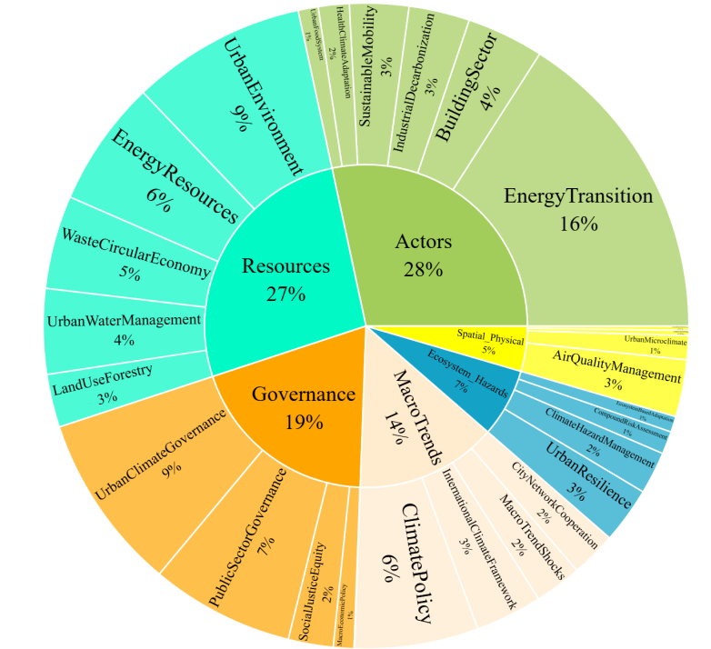

Figure 1. Hierarchical Sunburst Diagram of the Distribution of Interpretive Codes across the Six SES Themes

Analysis of Endogenous Systems (Resources, Actors, Governance, and Spatial-Physical)
The Actors system, with the highest statistical density recorded across the entire data matrix, emerges as the analytical focal point and key driver of urban transformative change. The interpretive component "Energy Transition," accounting for 56.2% of the frequencies within this domain, alongside the descriptive component "Energy Agents" with a 50.4% share, constitute the core of the policy discourse and demonstrate the strategic prioritization of systematic decarbonization of energy supply and consumption infrastructures. The complementary sectors of this agency domain include "Buildings" (13.6%), "Industrial Retrofit" (10.7%), and "Sustainable Mobility" (10.4%). Conversely, the negligible share of domains such as "Urban Food Systems" (3.6%) and "Health and Climate Adaptation" (5.4%) indicates the persistent dominance of mitigation-oriented approaches over bio-social adaptation strategies at the level of urban agencies, suggesting that adaptive and biological measures remain marginal to structural and technological emission control approaches.
The Resources system, with 1,244 interpretive codes, as the second strategic component, signifies the adoption of a multifaceted and holistic approach to urban metabolism. Within this framework, the interpretive codes "Urban Environment" at 32.8% and "Energy Resources" at 23.7% account for the highest frequency shares. At the descriptive code level, a systematic and structured convergence among environmental indicators (32.2%), energy (25.3%), waste (17.3%), and water (14.7%) is evident, reflecting a transition from unidimensional approaches toward a systemic and integrated perspective in addressing urban ecological cycles. Accordingly, the concepts of "Circular Economy and Waste Management" at 17.5% and "Hydrological and Urban Wastewater Management" at 16.0% are defined as key strategies for pollution control and the preservation of peri-urban biodiversity, while the "Land Use and Forestry" component, with a 10.0% share, occupies a lower tier in the implementation priority hierarchy.
The Governance system, with 903 interpretive codes, reflects a remarkable "institutional awakening." Findings indicate that the "Urban Climate Governance" component at 45.8% and "Public Sector Management and Steering" at 37.1% establish the central and exclusive role of local institutions and formal administrative structures in directing and orienting climate planning processes. Furthermore, the allocation of 11.6% of the codes in this domain to "Social Justice and Equity" signifies the increasing integration of social and distributive development criteria into the core of urban policymaking. In stark contrast to this institutional-social predominance, the "Climate Finance" component, with a share of merely 0.1% (i.e., only 1 interpretive code across the entire corpus of documents), is identified as the most critical structural-operational bottleneck. This profound imbalance reveals the fundamental gap between the theoretical requirements articulated in the documents and the actual implementation capacities in the domains of capital mobilization, financial risk management, and the deployment of innovative financing mechanisms for climate projects.
The Spatial-Physical system, with the lowest frequency recorded among all systems (211 interpretive codes; 4.5%), signifies the strategic lag of physical intervention domains compared to institutional and procedural reforms. This condition clearly demonstrates that physical-morphological analyses have ceded their former position to macro-metabolic and functional assessments grounded in agency and resource flows. Within this framework, the interpretive component "Air Quality Management," accounting for 63.0% of the total codes in this domain, occupies an indisputable primary priority, reflecting the policy focus on controlling criteria pollutants such as particulate matter (PM), nitrogen oxides (NOx), and tropospheric ozone. "Urban Microclimate" indicators, with a 26.5% share, occupy the subsequent tier, examining the interplay of urban form, surface albedo, and thermal comfort. At the bottom of this hierarchy, the components "Urban Form Design" at 5.7% and "Green-Blue Infrastructure" at 4.7% are situated, indicating that modifications to physical geometry and the development of natural-biological infrastructures have yet to become established as frontline instruments within the macro-strategic framework of social-ecological systems, with adopted approaches predominantly assuming processual-functional rather than physical-structural characteristics.

Analysis of Exogenous Systems (Macro Trends and Ecosystems & Hazards)
The systematic examination of interpretive codes attributed to the exogenous system reveals the formation of two distinct yet intertwined discursive currents in response to environmental forces and transnational actors, which condition the framework of urban action.
The Macro Trends domain, comprising 661 interpretive codes, exposes the structural dependence of local decision-making on the supraordinate normative system. Within this context, the quantitative dominance of the two components "Climate Policy" at 43.7% and "International Climate Frameworks" at 23.6%—which collectively account for more than two-thirds of the coding space in this section—indicates the profound influence of local agendas by the normative requirements of global supraordinate documents (such as the Paris Agreement, the Sendai Framework, and the assessments of the Intergovernmental Panel on Climate Change) and the transnational commitments arising from membership in climate networks. Alongside these supraordinate components, the indicators "City Network Cooperation" at 16.0% and "Macro Shocks" at 16.6% explicitly represent the strategic agency of metropolises in the realm of urban diplomacy and the development of transnational coalitions (such as the C40 network, ICLEI, and the Global Covenant of Mayors) as effective mechanisms for mitigating the consequences of geopolitical exogenous shocks, supply chain disruptions, and demographic-economic pressures. This statistical configuration demonstrates that cities, despite increasing local authority, remain defined within a framework of institutional interdependence with the multi-level governance system, and any departure from these frameworks risks delegitimization and exclusion from the flow of international green investments.
In contrast, the Ecosystems & Hazards theme, with 320 interpretive codes, represents a fundamental discursive shift from reactive hazard management toward the strengthening of systemic resilience and institutional capacity-building in the face of climate uncertainties. The "Urban Resilience" component, with 40.9% of the frequencies in this domain (131 codes), ranks first and signifies the transition from purely passive approaches based on damage control toward the enhancement of shock absorption capacity, rapid recovery, and dynamic adaptive capacity in urban socio-physical systems. Subsequently, the 30.9% share of "Climate Hazard Management" and the 16.6% share of "Compound Risk Assessment" indicate the movement beyond univariate analytical approaches toward a systematic understanding of concurrent hazards and cascading effects—an approach in which the simultaneity of heatwaves, droughts, and floods is examined as a network of intersecting risks with compounding impacts on critical urban subsystems (water, energy, transport, and health). However, the relatively modest share of "Ecosystem-based Adaptation (EbA)" at 11.6% of the interpretive codes in this domain (37 frequencies) indicates the persistent dominance of hard engineering approaches and grey infrastructure over nature-based solutions within the corpus of policy documents. This situation clearly demonstrates that despite the growing theoretical acceptance of ecosystem services in contemporary scientific literature, ecological strategies (such as wetland restoration, permeable pavement development, and the construction of green-blue networks) have yet to become established as a hegemonic and frontline approach in strategic urban climate documents, remaining marginal to hardware strategies based on resilient structures and mechanical systems. All changes are illustrated in Table 1 and Figures 1 and 2.

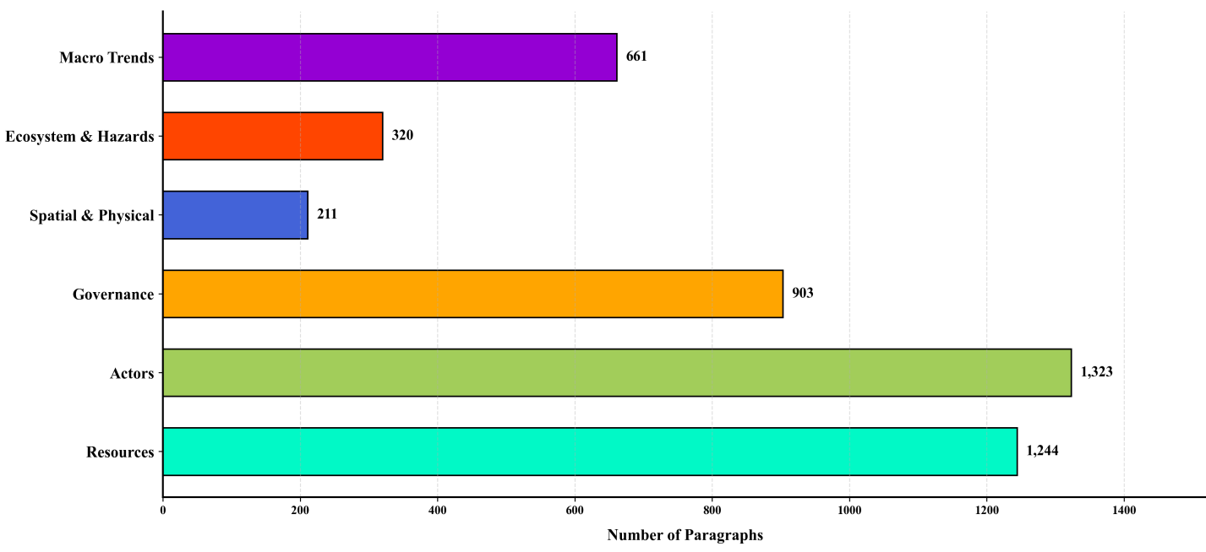 Figure 1. Distribution of the Six SES Themes across Selected Cities' Climate

Analysis of Macro-Conceptual Trends and Action Priorities
Examination of the ten most frequently recurring concepts across the documents provides a clear depiction of the primary priorities of the leading cities (Figure 3). At the apex of this ranking, the concept of "Energy Transition" appears with 744 repetitions. This predominance indicates that the cities under investigation consider decarbonization of the energy sector as the principal pathway toward achieving net-zero emissions. In practice, this concept encompasses a broad spectrum of measures: from the substitution of fossil fuels with renewable energy sources and the expansion of district heating systems, to the electrification of transport and the deployment of heat pumps. In other words, cities have transcended symbolic and voluntary initiatives and have entered the phase of structural interventions within the energy system.
In subsequent rankings, the concepts of "Urban Climate Governance" (414 repetitions) and "Public Sector Governance" (335 repetitions) occupy the second and fourth positions, respectively. This prominent presence signifies a departure from centralized state-level decision-making toward local and network-based governance. Municipalities, drawing upon local institutions, private sector engagement, and collaboration with inter-city networks such as C40, are striving to achieve greater autonomy in climate policymaking and to move beyond their role as mere implementers of national legislation.
One of the most noteworthy findings of this research is the pronounced decline in the standing of "International Climate Frameworks." This concept has dropped to tenth place with merely 156 repetitions, whereas in the macro-reports of the Intergovernmental Panel on Climate Change (IPCC), it consistently ranks among the highest. This shift indicates that cities have moved beyond the phase of symbolic commitments and international legitimacy-building, entering instead the phase of operational implementation at the local scale. The Paris Agreement and analogous documents, while establishing overall direction, have ceded their place in day-to-day urban planning to indigenous instruments, local institutions, and tangible solutions.
On the other hand, the absence of concepts such as "Climate Hazard Management," "Air Quality," and "Compound Risk Assessment" from among the top ten concepts—though seemingly surprising at first glance—is entirely comprehensible within the context of these transformations. This absence demonstrates that urban management has transcended the stage of hazard identification and description, now occupying the phase of direct intervention and systemic reform of energy systems, transportation, and local institutions. To put it more succinctly, leading cities no longer deliberate "about" climate risks; rather, they have undertaken fundamental changes "within" the systems that generate these risks. This repositioning reflects the maturation of urban climate policymaking and its progression from theoretical discourse toward practical action and resource allocation.
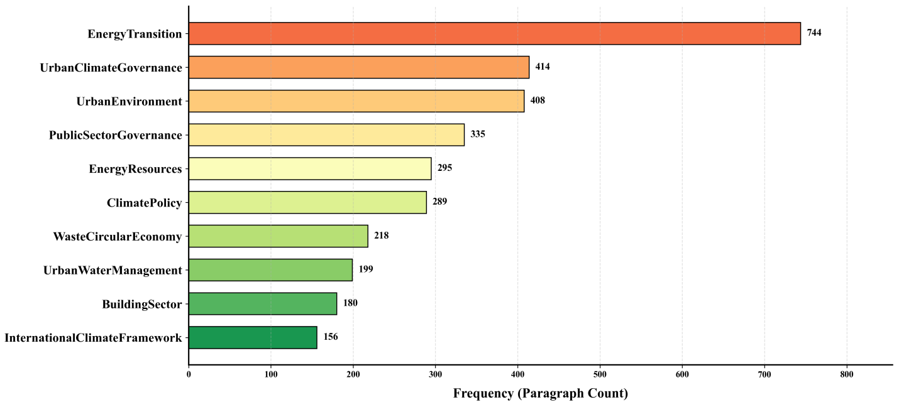
Figure 3. Bar Chart of the Ten Most Frequent Interpretive Concepts in the Documents of Selected Cities

Analysis of Systemic Integration Based on the Co-occurrence Network Graph
The analysis of the semantic linkage network graph of interpretive codes (Figure 4) enables the dissection of the latent knowledge architecture embedded within the policy documents. With a density of 0.119, this graph indicates a relatively open structure comprising specialized clusters yet lacking complete integration, reflecting the multi-faceted yet compartmentalized nature of urban climate literature at the level of implementation documents.
The densest segment of this network is formed at the intersection of concepts pertaining to "Actors" and "Governance." The robust ties among energy, transport, and industry variables with urban governance convey a clear analytical implication: within contemporary climate literature, advancing emission reduction targets in physical infrastructures is deemed unattainable without the direct and proactive intervention of public institutions and a concomitant focus on social development. The significant presence of the "Health" node at the core of this cluster further corroborates that citizen well-being and the reduction of biological vulnerabilities function as an intermediary nexus between agency performance and the quality of public sector decision-making.
Notwithstanding this dense core, the network graph also exposes analytical fractures. The "Macro Trends" cluster (encompassing international frameworks, macro shocks, and city networks) resides in network isolation, revealing a substantial disconnect between international diplomacy and intra-urban implementation realities. This finding indicates that despite theoretical advancements at the global level, effective mechanisms for translating international commitments into tangible actions at the city level have yet to materialize. Furthermore, the "Resource Base" concepts (water, waste, land use) form an independent cluster in a separate quadrant, signifying the siloed and engineering-oriented management of these domains and their lack of integration with the social and governance strategies of the energy transition. The "Urban Morphology" node functions as a connective bridge, linking the Actors cluster to microclimate and air quality, thereby elucidating the determinant role of spatial organization in mitigating urban heat islands and managing airflow dynamics.
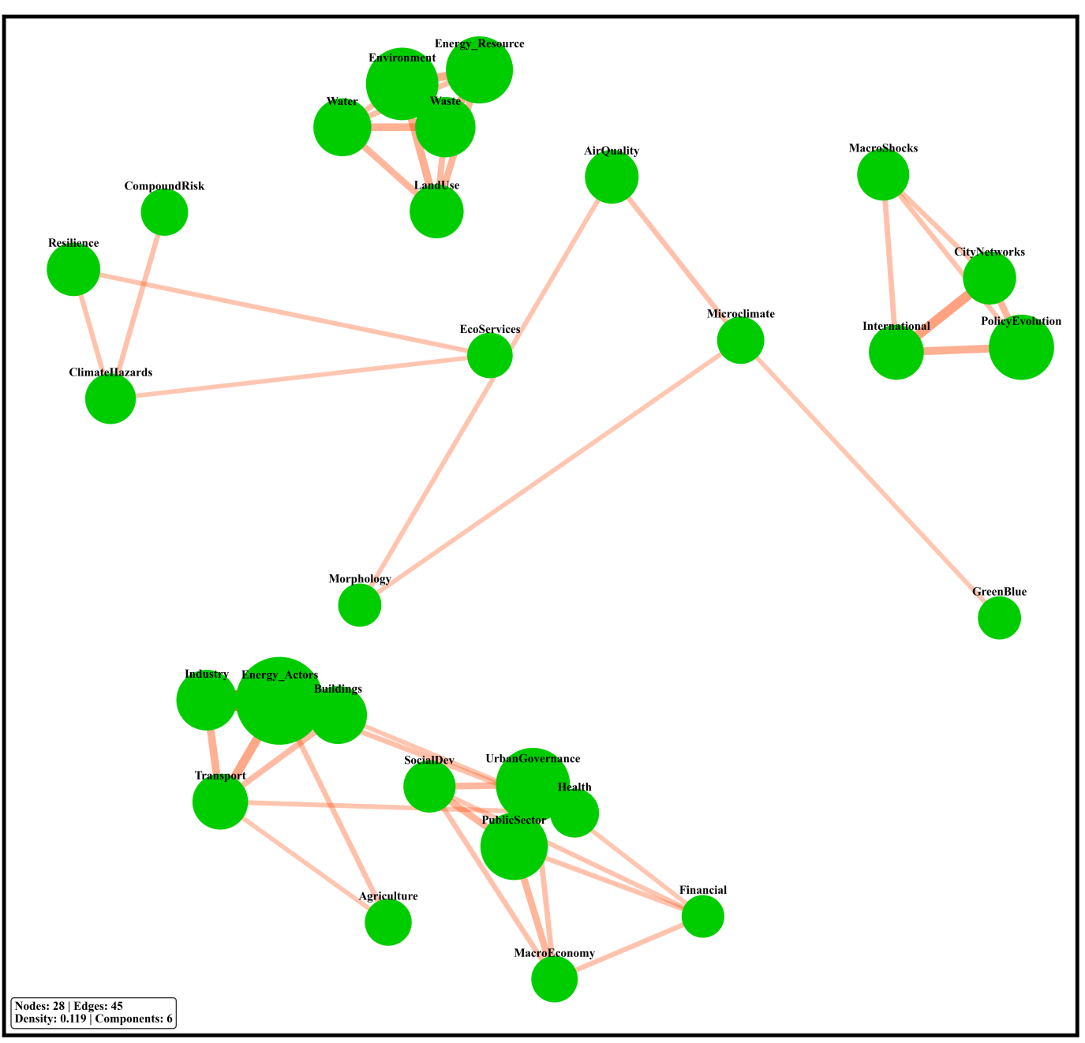
Figure 4. Network Graph of Conceptual Linkages

Analysis of Spatial-Conceptual Distribution Density Based on the Ridge Plot
The analysis of the ridge density plot reveals the distribution pattern of concepts within the internal structure of the documents (Figure 5). Examination of the morphology of these curves demonstrates three distinct behavioral patterns, each carrying profound methodological and policy implications:
The First Pattern, Multi-modal Cross-cutting Concepts: Codes such as "Air Quality Management," "Compound Risk Assessment," and "Energy Transition" exhibit elongated curves with uniform distribution across the progression axis of the documents. These concepts function as "cross-cutting" themes that flow throughout the texts—from problem articulation to solution presentation—constituting the structural backbone of climate documents. This widespread distribution confirms that issues such as air quality and energy constitute fundamental prerequisites for any climate action, maintaining a continuous and determining presence across all stages of document development.
The Second Pattern, Uni-modal Localized Concepts: Codes such as "Urban Cooperation Networks," "Urban Form Design," and "Circular Economy and Waste" display extremely sharp and confined peaks in specific sections of the documents (typically in the introductory or middle sections). This point-specific concentration indicates the emergent or peripheral nature of these concepts, which have yet to permeate as overarching concerns throughout the entire document structure. Despite their high potential for impact, these domains remain in the early stages of integration into the mainstream climate policy discourse and require further expansion and deepening within the urban planning literature.
The Third Pattern, Right-skewed Distribution: Codes such as "International Climate Frameworks" and "Macroeconomic Policy" exhibit dense peaks in the introductory sections of the documents. This pattern indicates that climate documents typically commence with the articulation of macro policies, international treaties, and economic outlooks, and only after establishing these supraordinate frameworks in the preamble do they proceed to more granular physical and implementation-oriented topics in subsequent pages. This textual architecture substantiates the dominance of a "top-down" approach in the narrative structure of the documents—an approach that, despite paradigmatic shifts in policy content, continues to cast its shadow over the compositional framework of the documents and may be considered among the obstacles to the realization of participatory and decentralized approaches.
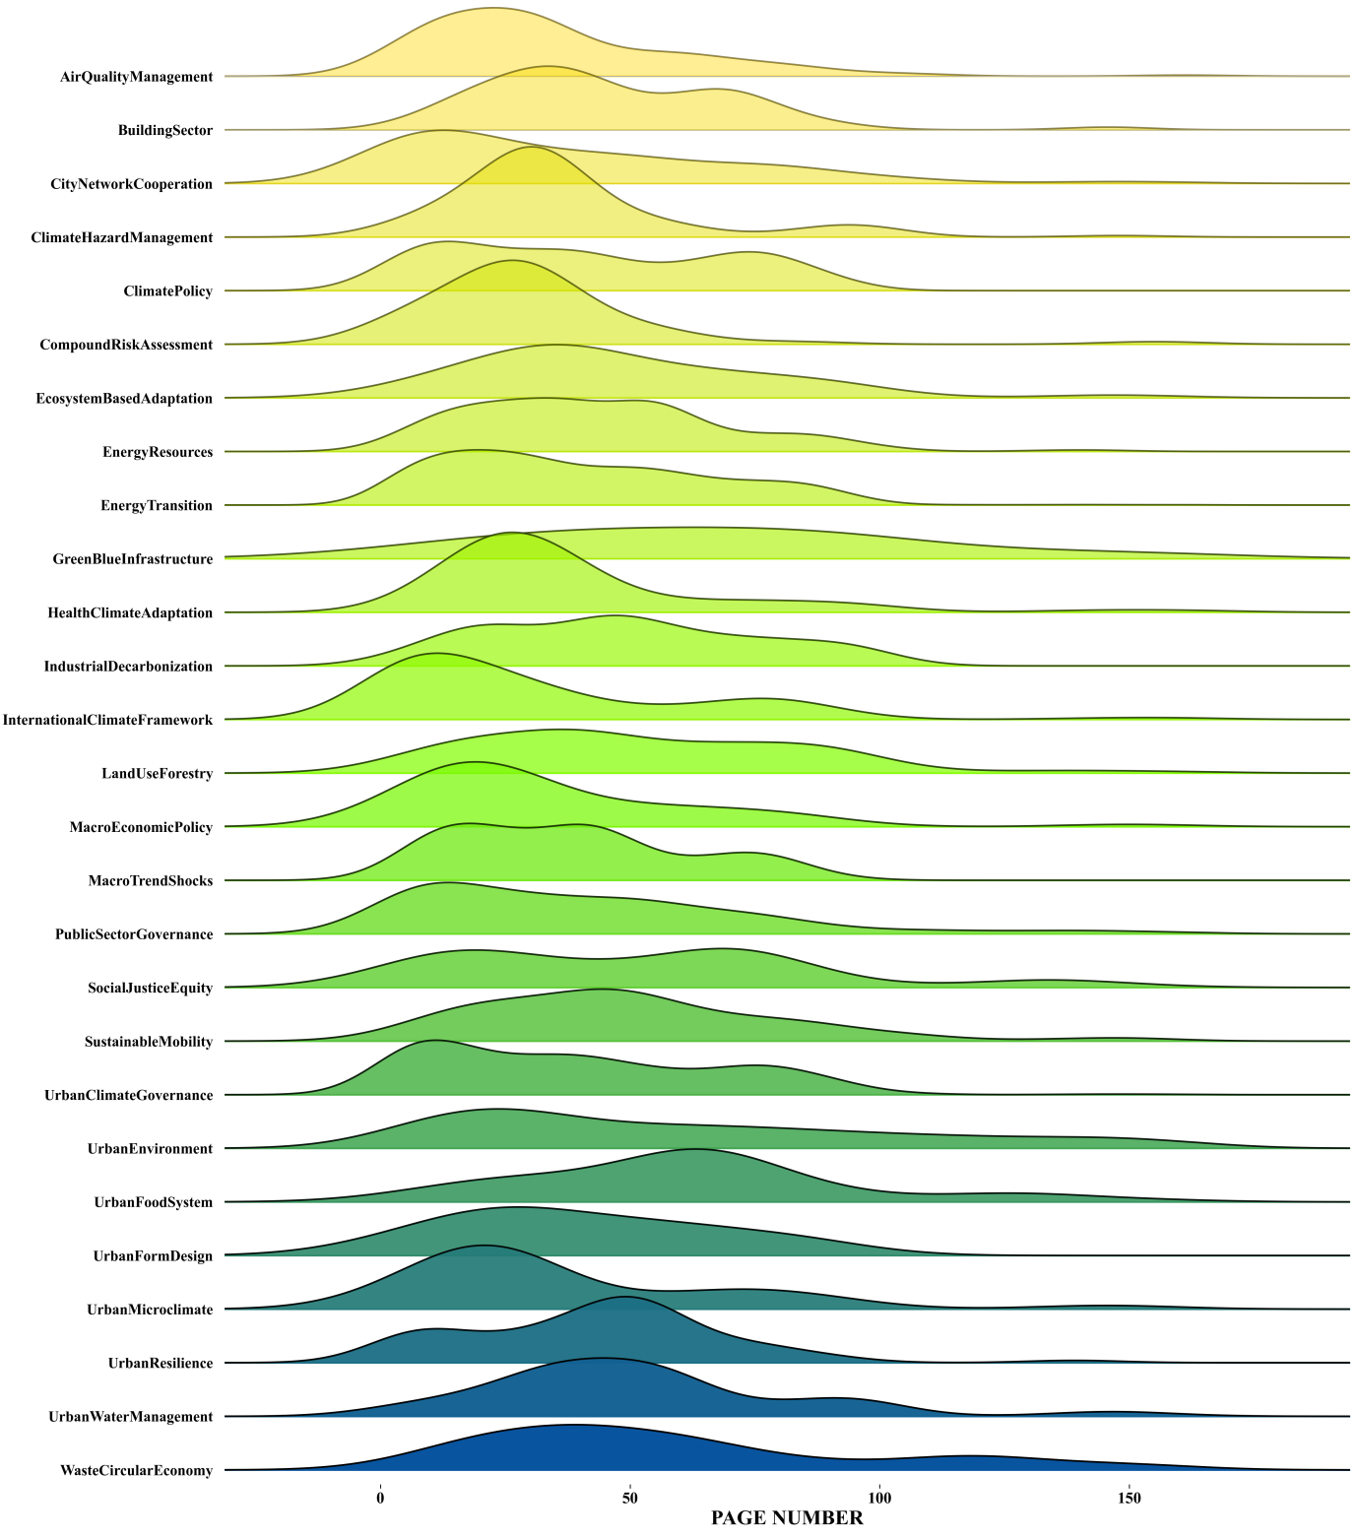
Figure 5. Density Distribution Patterns of Strategic Concepts across the Progression of Climate Action Documents

Discussion
The findings of this research reveal a tangible paradigmatic shift within the climate action documents of the world's leading metropolises—a phenomenon conceptualized in the policy literature as "urban pragmatism in climate governance." In contrast to traditional paradigms that positioned physical fabric and natural hazard monitoring at the center of analysis, the data matrix of this study demonstrates that the core of action plans is now anchored in "agencies" and "local governance." Such an epistemological turn is entirely consistent with the contributions of Aboagye and Sharifi (2026, 2023), who, through their analysis of post-AR5 trends, demonstrated that urban plans have progressively moved beyond the mere description of vulnerabilities toward offering operational solutions in the domains of infrastructure and energy. The strategic focus of the documents examined in the present study on the "Actors" theme (with a 28.4% share) and the predominance of "Energy Transition" (56.2%) within this system precisely corroborate the analyses of Aboagye and Sharifi (2023), which showed that the bulk of cities' planning capacity is directed toward decarbonizing transport and energy sectors. Nevertheless, this agency-oriented concentration, while indicative of technological maturity, aligns with the warnings of Cohen et al. (2025) concerning the emergence of "Structural Myopia." The allocation of over half of the strategic capacity to the energy sector has resulted in the marginalization of other vital arteries of urban metabolism—such as waste management, water resources, and food security—a deficiency clearly evidenced by the negligible share of urban food systems (merely 3.6%) recorded in the findings of this study.
In addition to the imbalance within the Actors system, the registration of the lowest number of interpretive codes in the "Spatial-Physical" system (4.5%) and the remarkably low share of variables such as Urban Form Design (5.7%) and Green-Blue Infrastructure (4.7%) reveal a profound fissure in the physical approach of leading cities. While recent studies—such as those by Ashione et al. (2025) and Ricciardi et al. (2025)—emphasize the multifunctional capacity of green spaces in simultaneously advancing mitigation and adaptation objectives, the documents under review continue to adopt a processual and reactive perspective toward urban morphology. The roots of this spatial deficiency can be traced to the findings of Haarstad et al. (2024) regarding the "limitations of soft governance." Their analysis of thousands of climate actions within the C40 network demonstrates that strategies in developed cities predominantly rely on incentivizing and voluntary measures, with hard regulatory instruments and material-physical interventions accounting for a negligible share of the plans. The direct consequence of such an approach, as Novak et al. (2024) have argued in their comparative study of European cities, is the formulation of documents with ambiguous guidelines that fail to translate abstract climate objectives into explicit spatial development policies and integrate them into comprehensive urban plans.
Alongside physical fissures, the most significant paradox extracted from the dissection of the six metropolises' documents is the acute tension between institutional ambitions and financial realities. While the Governance system commands a substantial share of analytical codes (19.4%), the allocation of a mere 0.1% to "Climate Finance" signals the emergence of a critical operational bottleneck. This imbalance corroborates the empirical evidence of Ravazzoli et al. (2026) and Gómez-Minguela et al. (2026), who demonstrated that in local strategies, limited financial resources are heavily concentrated in infrastructural and hardware sectors, while facilitating and institution-building measures suffer from severe funding deficits. The persistence of this financial void substantially undermines the effectiveness of the documents—a phenomenon reflected in the comprehensive evaluation by Aboagye and Sharifi (2024) of 257 action plans, where over half of the programs received moderate or poor scores in terms of integration, sustainability, and inclusiveness indicators.
The analysis of systemic integration based on the conceptual linkage network graph (with a density of 0.119) likewise reveals a relatively open structure with specialized yet organically disconnected clusters. The high density of the network at the intersection of "Actors" and "Governance" concepts confirms that advancing decarbonization programs is unattainable without the direct intervention and regulatory oversight of public institutions. In this context, the positioning of the "Health" node at the core of this cluster indicates the mediating role of citizen well-being in linking infrastructure performance with the quality of governmental decision-making. Nevertheless, the network graph reveals the complete isolation of the "Macro Trends" cluster—a disconnection that reflects the serious gap between international diplomatic treaties and local implementation realities, neutralizing the capacity to translate macro-objectives into spatial policies. On the other side, although the "Urban Morphology" node functions as a connective bridge linking the Actors cluster to microclimate and air quality, thereby elucidating the determinant role of spatial organization in mitigating heat islands, the concepts associated with "Resource Base" (water, waste, land use) form a completely independent cluster, indicating that the management of these vital arteries remains isolated and engineering-oriented, failing to integrate into overarching governance strategies.
The spatial-conceptual distribution patterns in the ridge plot further corroborate these structural dualities. While cross-cutting concepts such as "Air Quality Management" and "Energy Transition," with their multi-modal distribution, constitute the structural backbone of the documents—an approach crystallized in the pioneering projects of Stockholm and Copenhagen—concepts such as "Urban Form Design" and "Circular Economy," with their unimodal concentration, remain on the periphery of the dominant discourse. Within such an imbalanced structure, as Caggiano et al. (2026) have cautioned, the monitoring of physical metrics supersedes indicators of "social justice and inclusiveness." The modest 11.6% share of "Social Justice and Equity" in the present study corroborates the assertion that achieving resilience necessitates moving beyond purely technological solutions and establishing distributive justice within planning approaches. Ultimately, the synthesis of these findings demonstrates that the effectiveness of urban climate action plans is less contingent upon advanced technologies or international commitments than upon institutional alignment, the establishment of semi-autonomous energy agencies, the diversification of financial resources through Energy Performance Contracts (ESCOs), and the equitable redesign of physical spaces.
Conclusion and Suggestions
The systematic dissection of Climate Action Plans (CAPs) in the world's leading metropolises reveals a profound paradigmatic shift in confronting the phenomenon of climate change. This research demonstrated that the dominant discourse has transitioned from reductionist, descriptive, and monitoring-oriented approaches (reliant solely on hazard identification) toward agency-based, actor-oriented approaches grounded in energy demand management. Nevertheless, quantitative and network analyses substantiated that these documents, at the global level, continue to grapple with deep structural fissures. The marginalization of interventions within the spatial-physical system, the fragmented and siloed management of resource bases (particularly water and waste), the detachment of international diplomacy from local realities, and—most critically—the pronounced vacuum in operational climate finance mechanisms constitute systemic barriers that cast doubt on the effectiveness of urban action plans even in developed countries.
These global lessons and discursive fissures, extending beyond a mere comparative analysis, carry vital policy and practical implications for urban governance systems in developing countries. Extracting the roadmap of pioneering cities and critically recalibrating it for the metropolitan context suggests that the formulation of any successful action plan is contingent upon the implementation of a set of locally-adapted transitions across four fundamental dimensions:
1. Transition from Sectoral Management to Integrated Governance of Urban Metabolism: Successful global models demonstrate that climate actions must be anchored in "urban environment" as a unified platform, grounded in the structural nexus of water-energy-food. Within the Iranian urban governance structure—where the management of water flows, waste, energy, and air quality is dispersed across fragmented ministerial portfolios and municipal subdivisions—institutional integration across these dimensions and departure from decision-making silos constitute a fundamental prerequisite for navigating intersecting and compound climate crises.
2. Transition from Supply-Led Planning to Demand-Led Models and Agile Institutionalization: Iranian metropolises have for decades been managed under a linear logic of energy and water supply from distant watersheds and power plants. Transforming this pattern necessitates a focus on reshaping urban actor behavior, upgrading rigorous building envelope standards, and developing decentralized production capacities (e.g., small-scale solar installations on public building rooftops). The experience of cities such as Barcelona and London demonstrates that accelerating this objective hinges upon the establishment of semi-autonomous energy agencies and local demand management organizations within municipal structures.
3. Diversification of Financial Instruments and Breaking Credit Bottlenecks: Given the modest share of public budgets and international constraints on environmental projects, urban governance must move, through benchmarking against innovative mechanisms, toward structures that underwrite green investment risk for the private sector. The development of Energy Performance Contracts (ESCOs), the establishment of local revolving loan funds, and the issuance of green bonds represent strategies that can finance the substantial costs of infrastructure retrofitting through future real energy savings.
4. Consolidating Nature-based Solutions (NbS) at the Forefront of Physical Design: Given the rigidity of the concrete fabric in metropolises, the intensification of urban heat island effects, and infrastructure obsolescence, the redefinition of urban form should not be limited to merely cosmetic projects. The development of green-blue infrastructure, the preservation of remaining gardens and green spaces, the creation of sponge parks for flood mitigation, and the implementation of models such as natural ventilation corridors must be regarded as primary frontline strategies for climate adaptation and resilience within comprehensive urban plans.
In sum, the findings of this research confirm that the effectiveness of urban climate action plans, far from being contingent upon unattainable technologies or symbolic supraordinate documents, depends fundamentally upon institutional alignment, intelligent financing, spatial redesign integrated with distributive justice, and the alleviation of energy poverty in vulnerable areas. Future research could contribute to the advancement of climate policy knowledge in this region by focusing on the contextualization of the SES framework for developing metropolises and comparatively examining the alignment of urban plans with justice and integration indicators. Furthermore, comparative studies of institutional and financial barriers to CAP implementation in cities with analogous politico-economic contexts could yield more effective operational solutions. This study provides policymakers and urban planners with a coherent, data-driven framework to navigate the perilous path of transition toward a low-carbon, resilient, and human-centered future—by precisely understanding paradigmatic transitions and avoiding the repetition of historical trial and error.

Authors' Contribution
Mohammad Reza Farzaneh: Conceptualization, Acquisition of data, Analysis and interpretation of data, Drafting of the manuscript, Supervision. Faezeh Banimostafaarab: Conceptualization, Statistical analysis, Critical revision of the manuscript for important intellectual content, Review and refinement of methodology, Synthesis and interpretation of results.

Acknowledgments and Funding
This article is the result of independent research conducted by the authors and has not been supported by any organization. The authors used ChatGPT to improve the language, clarity, and readability of the manuscript. All scientific content, interpretations, and conclusions are solely the responsibility of the authors.

Conflict of Interest
The author(s) declares that there is no conflict of interest regarding the publication of the registered research. Furthermore, ethical considerations including plagiarism, informed consent, misconduct, fabrication and/or falsification of data, duplicate publication, and also Journal Policy on Artificial Intelligence Use have been fully observed by the authors.

Open Access
Copyright © 2026 The Author(s). This article is published under the terms of the Creative Commons Attribution 4.0 International License (CC BY 4.0), which permits use, sharing, adaptation, distribution, and reproduction in any medium or format, provided that appropriate credit is given to the original author(s) and the source, a link to the Creative Commons license is provided, and any changes made are indicated. Images, references, citations, or other third-party material included in this article are covered by the article’s Creative Commons license unless otherwise indicated in a credit line or note accompanying the material. If such material is not included under the article’s Creative Commons license, or if the intended use exceeds the permitted use under statutory regulation or the license terms, permission must be obtained directly from the copyright holder.
To view a copy of this license, please visit:
http://creativecommons.org/licenses/by/4.0

Publisher’s Note
The publisher of the JCCSDR remains neutral with regard to jurisdictional claims in published maps.

References
Aboagye, P. D., & Sharifi, A. (2023). Post-fifth assessment report urban climate planning: Lessons from 278 urban climate action plans released from 2015 to 2022. Urban Climate, 49, 101550.
https://doi.org/10.1016/j.uclim.2023.101550
Aboagye, P. D., & Sharifi, A. (2024). Urban climate adaptation and mitigation action plans: A critical review. Renewable and Sustainable Energy Reviews, 189, 113886.
https://doi.org/10.1016/j.rser.2023.113886
Aboagye, P. D., & Sharifi, A. (2026). Urban climate action planning case studies: A review of trends, approaches, and reported barriers and drivers. Journal of Environmental Management, 397, 128269.
https://doi.org/10.1016/j.jenvman.2025.128269
Aboagye, P. D., & Sharifi, A. (2026). Urban climate action planning case studies: A review of trends, approaches, and reported barriers and drivers. Journal of Environmental Management, 397, 128269.
https://doi.org/10.1016/j.jenvman.2025.128269
Ascione, L., Gargiulo, C., & Guida, C. (2025, June). A systematic review of climate action plans: A focus on urban green spaces for adaptation and energy saving. In International Conference on Computational Science and Its Applications (pp. 106-121). Cham: Springer Nature Switzerland.
https://doi.org/10.1007/978-3-031-97606-3_8
Ascione, L., Gargiulo, C., & Guida, C. (2025, June). A systematic review of climate action plans: A focus on urban green spaces for adaptation and energy saving. In International Conference on Computational Science and Its Applications (pp. 106-121). Cham: Springer Nature Switzerland.
https://doi.org/10.1007/978-3-031-97606-3_8
Barcelona City Council. (2018). Climate plan 2018-2030. Urban Ecology.
Caggiano, H., Lore, M., & Kocakuşak, D. (2026). What Do Cities Count? A Global Analysis of Indicators in Urban Climate Action Planning. Journal of City Climate Policy and Economy, 5(1), 45-64.
https://doi.org/10.3138/jccpe-2025-0036
City of Copenhagen. (2025). CPH 2025 climate plan: Copenhagen carbon neutral city. City of Copenhagen.
City of Paris. (2024). Paris climate action plan 2024-2030: Faster, more local, fairer.
Cohen, M., Baker, M., Bush, M., Ospina, A., & Powell, A. (2025). A review of US city climate action plans. Climatic Change, 178(4), 61.
https://doi.org/10.1007/s10584-025-03887-7
Cohen, M., Baker, M., Bush, M., Ospina, A., & Powell, A. (2025). A review of US city climate action plans. Climatic Change, 178(4), 61.
https://doi.org/10.1007/s10584-025-03887-7
Debbage, N., Atasoy, M., Mitra, C., & Byahut, S. (2024). Urban climate action plans in the United States: a textual content analysis and evaluation. Sustain Cities Soc 120: 106095.
https://doi.org/10.1016/j.scs.2024.106095
Element Energy Limited. (2022). Analysis of a net zero 2030 target for Greater London: Final report. Greater London Authority.
Flórez Bossio, C., Ford, J., & Labbé, D. (2019). Adaptive capacity in urban areas of developing countries. Climatic Change, 157(2), 279-297.
https://doi.org/10.1007/s10584-019-02534-2
Gómez Minguela, A. B., Bresciani, S., & Noera, F. M. (2026). Learning from 102 European Municipalities: Sectoral and Regional Patterns of Action Plans in Climate City Contracts. Climate, 14(2), 46.
https://doi.org/10.3390/cli14020046
Grafakos, S., Viero, G., Reckien, D., Trigg, K., Viguie, V., Sudmant, A., ... & Dawson, R. (2020). Integration of mitigation and adaptation in urban climate change action plans in Europe: A systematic assessment. Renewable and Sustainable Energy Reviews, 121, 109623.
https://doi.org/10.1016/j.rser.2019.109623
Greater London Authority. (2022, January). London net zero 2030: An updated pathway.

Haarstad, H., Grandin, J., & Solberg, R. R. (2024). Do cities have tools to meet their climate targets? The limits of soft governance in climate action plans. Cities, 151, 105142.
https://doi.org/10.1016/j.cities.2024.105142
Haarstad, H., Grandin, J., & Solberg, R. R. (2024). Do cities have tools to meet their climate targets? The limits of soft governance in climate action plans. Cities, 151, 105142.
https://doi.org/10.1016/j.cities.2024.105142
Heikkinen, M., Ylä-Anttila, T., & Juhola, S. (2019). Incremental, reformistic or transformational: what kind of change do C40 cities advocate to deal with climate change?. Journal of Environmental Policy & Planning, 21(1), 90-103.
https://doi.org/10.1080/1523908X.2018.1473151
Hsu, A., Tan, J., Ng, Y. M., Toh, W., Vanda, R., & Goyal, N. (2020). Performance determinants show European cities are delivering on climate mitigation. Nature Climate Change, 10(11), 1015-1022.
https://doi.org/10.1038/s41558-020-0879-9
https://www.c40.org/benefits-urban-climate-action/
Hughes, S. (2020). Principles, drivers, and policy tools for just climate change adaptation in legacy cities. Environmental Science & Policy, 111, 35-41.
https://doi.org/10.1016/j.envsci.2020.05.007
ICLEI - Local Governments for Sustainability, United Nations Environment Programme (UNEP), & United Nations Human Settlements Programme (UN-Habitat). (2009). Title of the guidebook/report.
Ipcc, C. C. (2014). Impacts, adaptation and vulnerability. Contribution of Working Group II to the Fifth Assessment Report of the Intergovernmental Panel on Climate Change. WGII AR5 Summary for Policymakers., Report No., IPCC, Geneva, Switzerland, 44.
Istanbul Metropolitan Municipality. (2021). Istanbul climate change action plan
Juhola, S., Heikkinen, M., Pietilä, T., Groundstroem, F., & Käyhkö, J. (2022). Connecting climate justice and adaptation planning: An adaptation justice index. Environmental Science & Policy, 136, 609-619.
https://doi.org/10.1016/j.envsci.2022.07.024
Lamb, W. F., Creutzig, F., Callaghan, M. W., & Minx, J. C. (2019). Learning about urban climate solutions from case studies. Nature Climate Change, 9(4), 279-287.
https://doi.org/10.1038/s41558-019-0440-x
Nowak, M. J., Bera, M., Lazoglou, M., Olcina-Cantos, J., Vagiona, D. G., Monteiro, R., & Mitrea, A. (2024). Comparison of urban climate change adaptation plans in selected European cities from a legal and spatial perspective. Sustainability, 16(15), 6327.
https://doi.org/10.3390/su16156327
Olazabal, M., & De Gopegui, M. R. (2021). Adaptation planning in large cities is unlikely to be effective. Landscape and Urban Planning, 206, 103974.
https://doi.org/10.1016/j.landurbplan.2020.103974
Rahmani, N., & Sharifi, A. (2025). Urban heat dynamics in Local Climate Zones (LCZs): A systematic review. Building and Environment, 267, 112225.
https://doi.org/10.1016/j.buildenv.2024.112225
Ravazzoli, E., Mioni, C., Lavarello Schettini, R., Cetara, L., Mucciarelli, L., Oberti, B., & Zebisch, M. Addressing Barriers in Climate Action Planning: An Analysis Based on Six Italian Territories. Frontiers in Climate, 8, 1828407.
https://doi.org/10.3389/fclim.2026.1828407
Reckien, D., Salvia, M., Heidrich, O., Church, J. M., Pietrapertosa, F., De Gregorio-Hurtado, S., ... & Dawson, R. (2018). How are cities planning to respond to climate change? Assessment of local climate plans from 885 cities in the EU-28. Journal of cleaner production, 191, 207-219.
https://doi.org/10.1016/j.jclepro.2018.03.220
Reckien, D., Salvia, M., Heidrich, O., Church, J. M., Pietrapertosa, F., De Gregorio-Hurtado, S., ... & Dawson, R. (2018). How are cities planning to respond to climate change? Assessment of local climate plans from 885 cities in the EU-28. Journal of cleaner production, 191, 207-219.
https://doi.org/10.1016/j.jclepro.2018.03.220

Ricciardi, G., Callegari, G., & Leone, M. F. (2025). 20∗ 20∗ 60: A multilevel climate change analysis framework. Journal of Environmental Management, 373, 123733.
https://doi.org/10.1016/j.jenvman.2024.123733
Sharifi, A. (2020). Trade-offs and conflicts between urban climate change mitigation and adaptation measures: A literature review. Journal of Cleaner Production, 276, 122813.
https://doi.org/10.1016/j.jclepro.2020.122813
Sharifi, A., Amirzadeh, M., & Khavarian-Garmsir, A. R. (2025a). The metaverse as a future form of smart cities: A systematic literature review of co-benefits and trade-offs for sustainable development goals. Cities, 161, 105879.
https://doi.org/10.1016/j.cities.2025.105879
Sharifi, A., Jin, Y., & Aboagye, P. D. (2025b). Mapping and topic modeling of over 133,000 studies on climate change and cities: Trends, geographical disparities, and future research needs. Urban Climate, 61, 102448.
https://doi.org/10.1016/j.uclim.2025.102448
Stockholm City Council. (2024). Climate action plan 2030: A just transition for a Stockholm with no global carbon footprint. City Executive Office.
Tiepolo, M. (2017). Relevance and quality of climate planning for large and medium-sized cities of the tropics. In Renewing local planning to face climate change in the tropics (pp. 199-226). Cham: Springer International Publishing.
https://doi.org/10.1007/978-3-319-59096-7_10
UNFCCC, 2022. About GCAP UNFCCC. https://climateaction.unfccc.int/about
Zhang, Z., & Sharifi, A. (2024). Analysis of decoupling between CO2 emissions and economic growth in China's provincial capital cities: A Tapio model approach. Urban Climate, 55, 101885.
https://doi.org/10.1016/j.uclim.2024.101885

AUTHOR(S) BIOSKETCHES
HOW TO CITE THIS ARTICLE:  DOI:  URL: |  | 

